**Section 1 - The Rotary Engine**

**1.1 Introduction**

A rotary engine is defined as an internal combustion engine, however, is different to the more common piston engine design since it can perform multiple jobs of an engine within a smaller volume. Within the same space accumulated by a cylinder within a conventional piston engine, the rotary engine can perform **intake**, **compression**, **combustion** and **exhaust**. The rotary engine does all these jobs continuously one after the other in their own sections within the housing.



*Figure 1 - Rotary Engine's Cycle*

[Animation Source](https://energyeducation.ca/encyclopedia/Rotary_engine)

**1.2 History & Development**

The rotary engine was created by Dr. Felix Wankel and his research into engine designs and manufacturing was originally commenced in 1951. His first design of the rotary engine was completed in 1954 for NSU Motorenwerke - a German manufacturer of automobiles, motorcycles and pedal cycles. Furthermore, the rotary engine is therefore, often referred to as the Wankel engine or Wankel rotary engine.

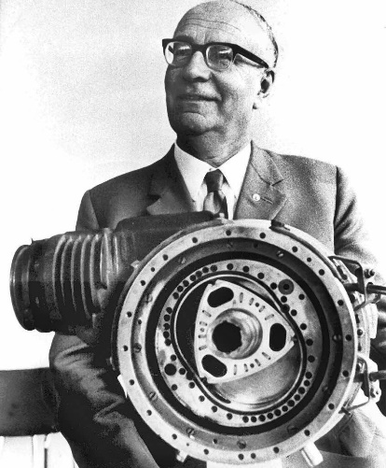

*Figure 2 - Dr. Felix Wankel*

[*Image Source*](https://www.pinterest.com.au/pin/128352658111602643/)

**1.3 How it Works**

A rotor as illustrated in *figure 1*, performs the previously discussed four operations within an oval shaped housing. The engine uses what is known as a four-stroke combustion cycle - as previously mentioned, this name comes from the four operations of the engine. The rotor is contained in a large oval shaped housing and the connecting output shaft (as seen as the labelled object "B" on the above *figure* 1) spins approximately **three times**faster than the rotor.

**1.3.1 The Rotor Cycle**

The rotor cycle can be broken down into the four operations as previously mentioned which in more detail involve:

1. **Intake** - The tip of the rotor passes the intake port and at this time the rotor's smallest sectional surface area is covering the port, followed by the transitioning larger area covering the intake port, during the rotation of the rotor - this draws in the air/fuel mixture.
2. **Compression** - The rotor proceeds turning, and the mixture of air/fuel becomes compressed since the chamber is decreasing in size - the rotor's shape, once again, inevitably will push its curved longer edge against the interior housing wall.
3. **Combustion** - The compressed blend gets ignited by start plugs and the increase in the pressure from the mentioned compression process. The force created causes the rotor to expand and hence, work has been done (). The two start plugs are employed within the engine to allow for even combustion. The exhaust gas expands into the chamber until the rotor has rotated past the exhaust port.
4. **Exhaust**- Upon the rotors rotation of the exhaust port the pressurized gases are able to flow through the exhaust port. The rotor will continue to spin until its larger edge has passed the exhaust port and the cycle rehashes as a corresponding tip of the rotor will be passing the intake port.

**1.4 Benefits**

The major beneficial aspect of the rotary design is that the cycle has all the operations occurring in near synchronous fashion within different sections of the chamber. Furthermore, the benefit of this design results in three power-strokes for every turn of the rotor.

Alike, the rotary engine has less moving components (and movement at slower speeds) - in comparison with a piston engine, which will have almost 40 moving components, a rotary engine will have only three moving parts. Less moving parts also means the engine is more reliable - less parts that can fail as there are less vital parts within the engine design.

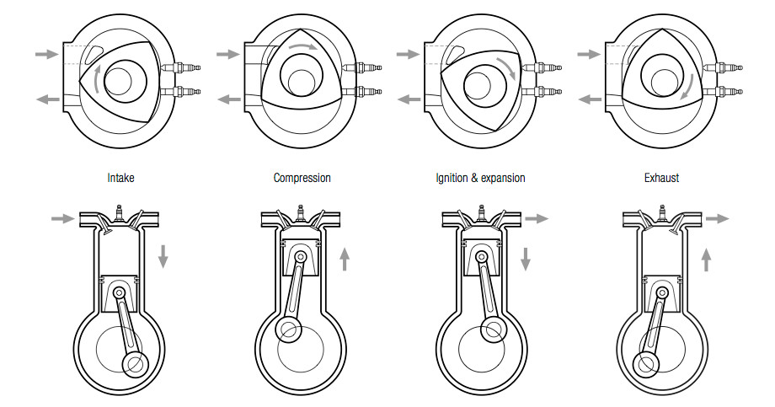

*Figure 3 - Rotary vs Piston Engine Movement*

[*Image Source*](https://www.torquingcars.com/general/tech-talk-what-is-a-rotary-engine/)

The rotary engine is also smoother with the rotor spinning in one direction constantly. In contrast with a piston engine whose components (pistons) change direction rapidly (see *figure 3*). Rotary engines are also counter-balanced (see *figure 4*) by weights that reduce the internal vibrations. Furthermore, the benefit of this smoother operation of the engine induces a more continuous power delivery.

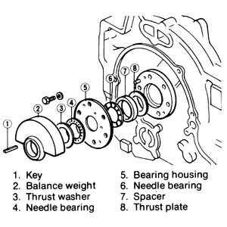

*Figure 4 - Balance Weight & Bearing Housing Assembly*

[Image Source](http://www.mazdabg.com/)

**References:**

[1] - J.M.K.C. Donev et al. (2018). Energy Education - Rotary engine [Online]. Available: https://energyeducation.ca/encyclopedia/Rotary_engine. [Accessed: April 30, 2021].

[2] - Mazdabg.com. n.d. *Disassembly of Internal Components*. [online] Available at: <http://www.mazdabg.com/ftp-uploads/Mazda/--Repair%20Instructions--/323%20929%20RX-7%20MX-6/8581R03_Disassembly_of_Internal_Componen.htm> [Accessed 30 April 2021].

[3] - Nice, K., 2021. *How Rotary Engines Work*. [online] HowStuffWorks. Available at: <https://auto.howstuffworks.com/rotary-engine.htm#pt3> [Accessed 30 April 2021].

[4] - Pallardy, R., n.d. *Felix Wankel | German inventor*. [online] Encyclopedia Britannica. Available at: <https://www.britannica.com/biography/Felix-Wankel> [Accessed 30 April 2021].